**CREATING AN SPONSERED INSTAGRAM POST**

NAAN MUDHALVAN ID: NM2023TMID10591

TEAM MEMBERS:

1. Harini K
2. Anushiya N
3. Hemavarshini K
4. Ranjitha S
5. Reshma J

ABASTRACT:

Instagram is an American photo and video sharing social networking service owned by Meta Platforms. It allows users to upload media that can be edited with filters, be organized by hashtags, and be associated with a location via geographical tagging. Posts can be shared publicly or with preapproved followers.

This project is about creating an sponsored Instagram post for the business page and brand promotion for a targeted set of people. The additional add on application and new feature of Instagram is it digital impacts on users. So now-a-days even brands and new emerging business started making use out of all these social media pages like Twitter, Instagram, FaceBook, Linkedin, etc., . In addition to mere creation of social media pages, every young budding brands requires user engage and brand promotion and growing sales point.

For such brand promotion, digital marketing can be done in a effective way to improve the brand growth.

**CREATING AN SPONSERED INSTAGRAM POST**

NAAN MUDHALVAN ID: NM2023TMID10591

INTRODUCTION:

When Instagram first launched, users could only upload photographs, but in 2013, users could also upload 15-second videos. Instagram increased the maximum video duration to 60 seconds in 2016. Every Instagram photo's actual aspect ratio had to be square until 2015, and the business changed this to allow subscribers to post full-size images and videos.

This project is about creating a mock clothing brand named RIYA FASHION for both category of men and women. The business page for RIYA_FAZ is created in Instagram and promotion ad through sponsored post is created for user engage and high sales.

DETAILED PROJECT REPORT:

BRAND NAME : Riya_Faz | Riya Fashion

CATEGORY : Clothing Brand

TARGETED AUDIENCE: All (Men, Women, and Kids)

EMAIL : [riya.faz.rf@gmail.com](mailto:riya.faz.rf@gmail.com)

INSTAGRAM PAGE : _RIYA_FAZ

YOUTUBE LINK : https://youtu.be/lbONqhWfWR8

(UPLOADED VIDEO)

DOCUMENTATION:

Screenshots taken while creating social media ads and sponsored post are attached below as follows,

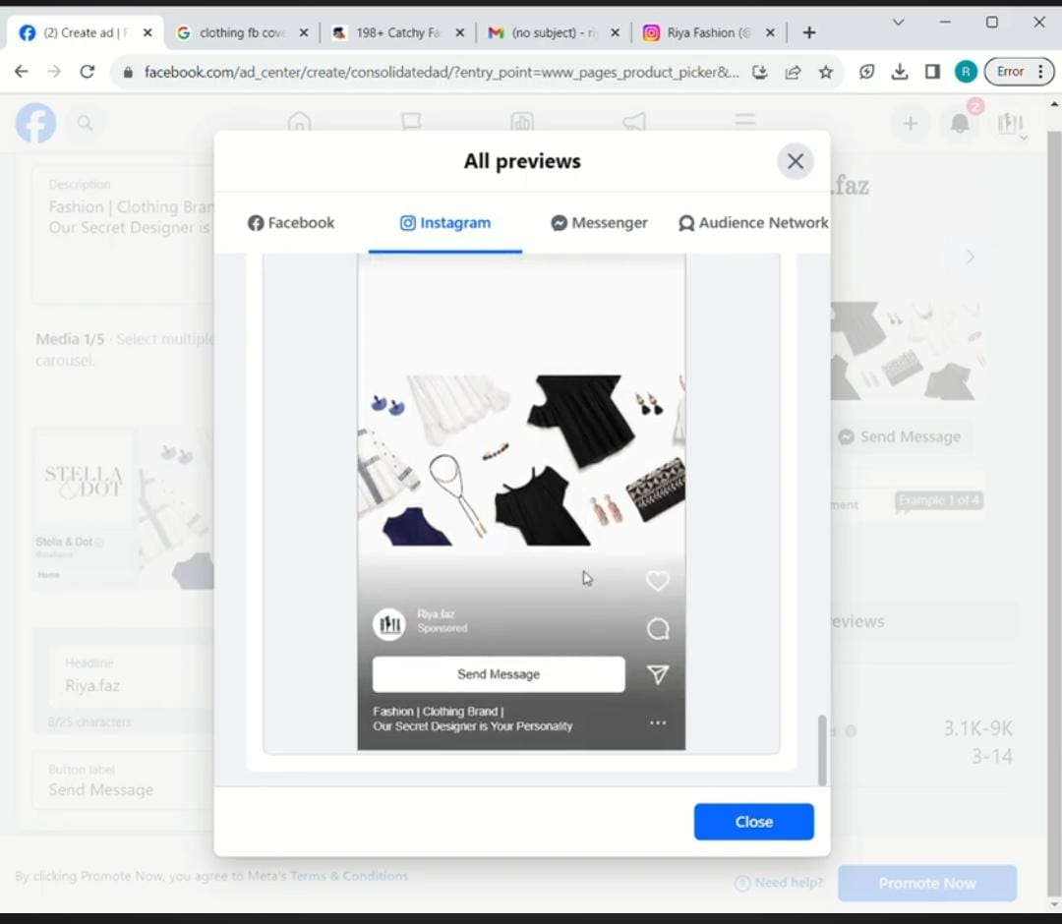

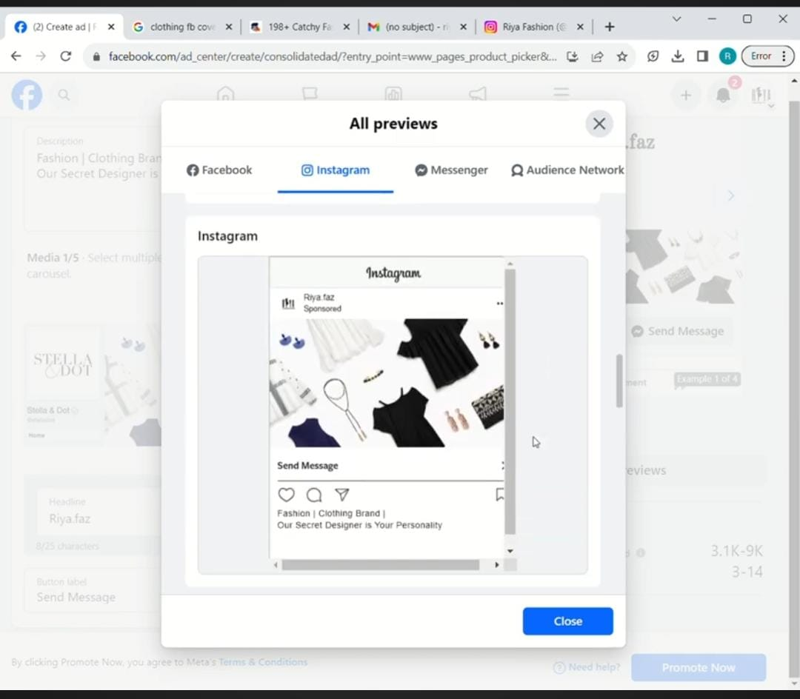

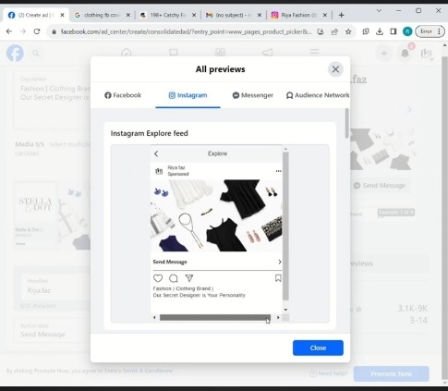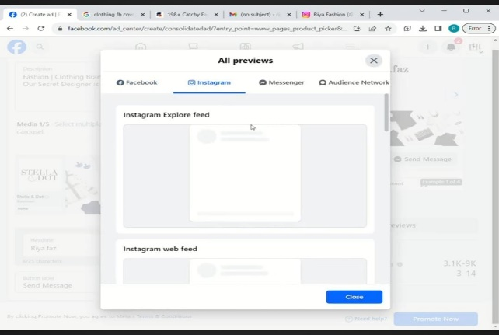

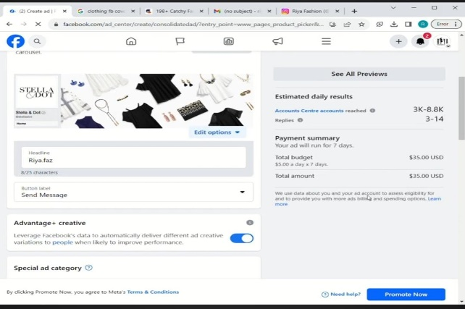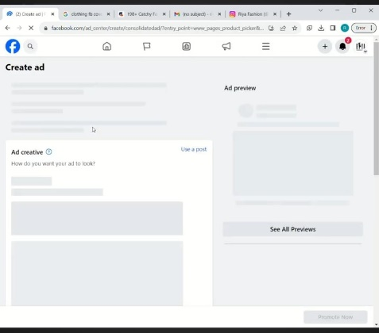

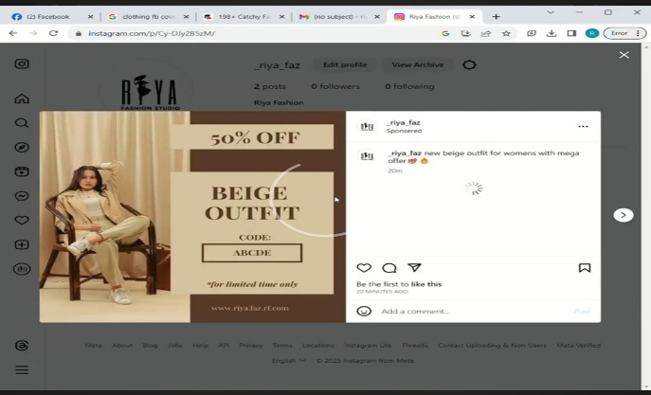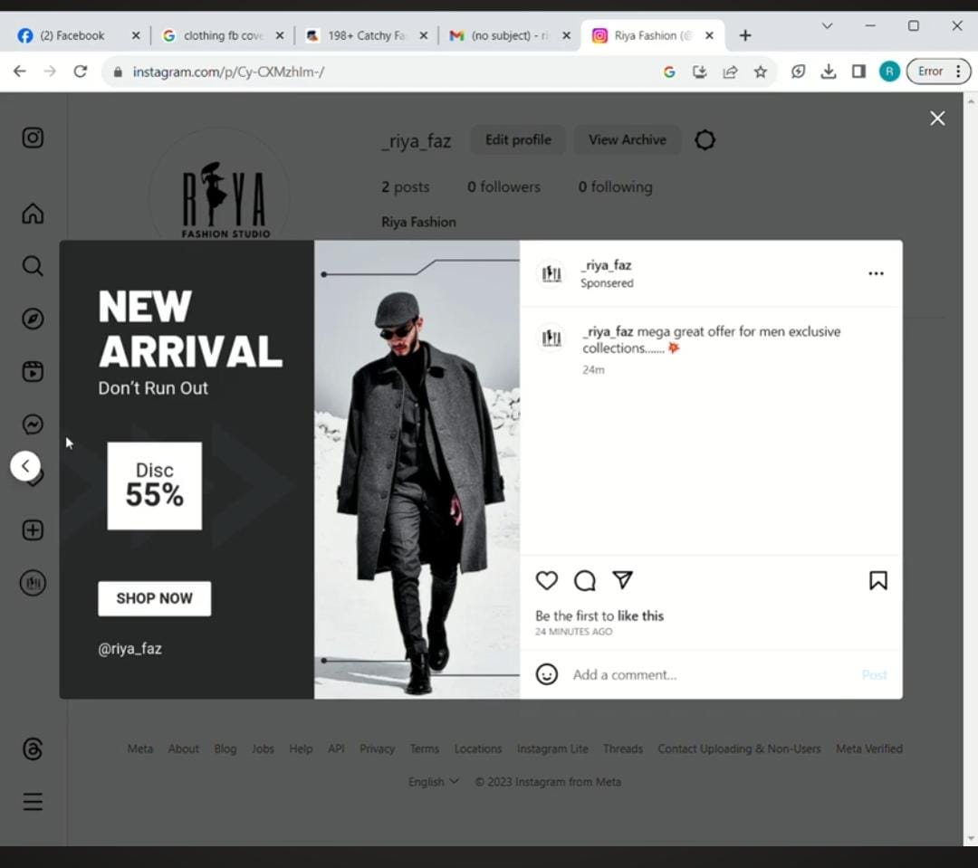

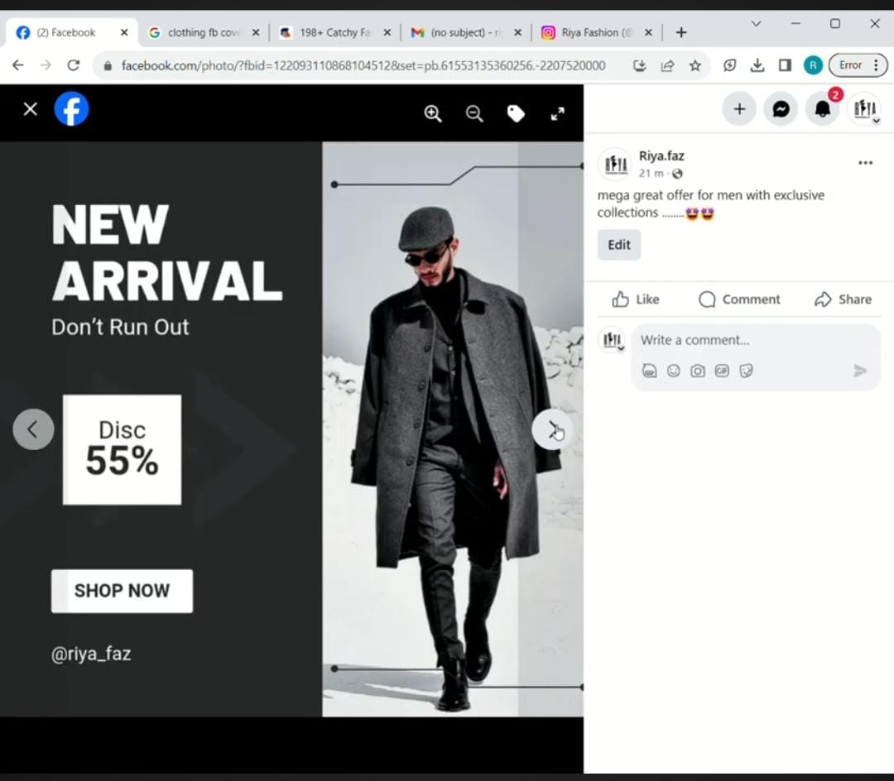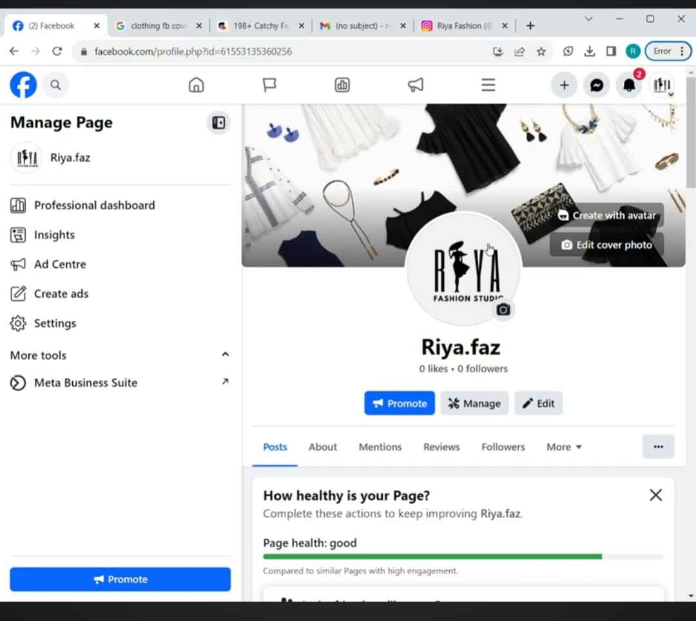

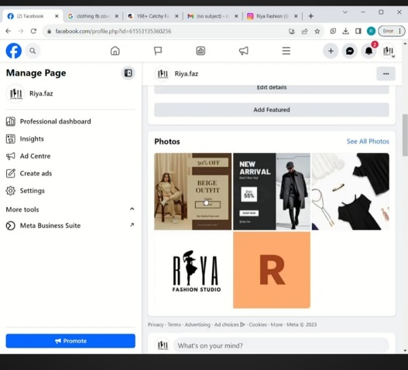

**SOCIAL MEDIA AD POSTER DESIGN:**

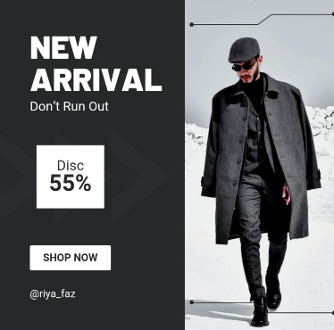

**RECORDED VIDEO:**

The recorded video of making process of this project on sponsored Instagram post is uploaded in youtube. The link of the uploaded youtube video is given down as follows,

**Youtube video link**: https://youtu.be/lbONqhWfWR8